MIDTERM REPORT

OF

Crime File System

**SUBMITED TO SUBMITTED BY**

**INDEX**

* **COMPANY PROFILE**

**Services Provided By INFOWIZ**

* **PYTHON INTRODUCTION**

**Applications of PYTHON**

**What is PYTHON**

**What can do PYTHON**

**Why PYTHON**

**PYTHON Features**

* **HARDWARE AND SOFTWARE TO BE USED**
* **SCOPE OF WEBSITE**
* **PROJECT DESCRIPTION**

**Modules**

**ScreenShot**

**ACKNOWLDEGEMENT**

The internship opportunity I had with **INFOWIZ industry Pvt. Ltd.** provided a great platform for learning, enhancing and developing professional skills in me. I feel extremely honored as I was provided with an opportunity to be a part of your esteemed organization. I am grateful for all the professionals and other members in organization who led me through this learning period. Without their support, this project would not have been possible.

I would like to extend my deepest gratitude and thanks from the core of my heart to **Mr. Kamaljot Kansal MD** who allowed and facilitated all support and help to carry my project in his esteemed organization.

I express my deepest thanks to **<Teacher name> <Designation>** for his useful decision in offering necessary advise and able guidance throughout during the course of making this project. I choose this opportunity to acknowledge his contribution gratefully.

My best and fond regards with deep sense of gratitude to **<Name>** for their everlasting and precious guidance, encouragement time to time which were extremely valuable for my theoretical and practical study.

I take this opportunity as a big milestone in my career development. I will always strive to use these acquired skills and knowledge in best possible manner and will continue to work on their improvement to attain the desired career objectives.

**COMPANY PROFILE**

**INFOWIZ** is leading strategic **IT Company** offering integrated IT solution. INFOWIZ is having rich experience managing global clients across various business verticals and align IT strategies to achieve business goals. The various accreditations that we have achieved over the years for every services, reflects our commitment towards the Quality Assurance.

**INFOWIZ** was founded in the year 2009 with the mission to provide Industrial training to aspiring Engineers and technical support to industries. Within a short span of 11 years “Infowiz” has become one of the leading organizations which offer state of art professional IT solutions, Industrial Trainings, technical support and consultancy to software companies in India and abroad. Due to quality assurance and high level of commitments in our services, we have won quite a few accolades and are associated with reputed universities and popular corporate, in this field. We strive to impart personalized, professional and contemporary experiential trainings to all the engineering streams that are necessary for the career, success and growth for both students & industry respectively.

We believe in**“Better Skills-> Better Jobs-> Better Life”**

Keeping in mind, requirement of present time, we have established a separate training and skill development wing for students that help them in providing exposure to industry and in getting real time practical knowledge of work. We have a pool of experts in our faculty specializing in specific areas that serve organizations of numerous industries. We offer training and learning that are tailored to provide solutions to help increase productivity, performance and profitability of organizations. Our courses offer in-depth coverage of specific and focused skills. We are also committed to place our students within various companies so that they can get dream job after completion of training.

**OUR TEAM:**

Our Technical team of professionals are already designing & delivering state of the art projects to its customers. **INFOWIZ** has a strong presence in the **North India & in US**. Our engineers are already working on the latest technologies namely **iPhone & Android Applications, Robotics, VLSI-VHDL, Embedded System, Networking and Cloud computing.**

**MANAGEMENT & LEADERSHIP:**

INFOWIZ is led by a team of professionals and technicians who are experienced enriched, committed and always ready to accept contemporary challenges. The leadership think tank comprises of the young and dynamic personalities with a distinct vision of improvising quality knowledge and skill development as core competencies among the budding engineers.

**1. Mr. Kamaljot Kansal (CEO)**

Mr. Kamaljot Kansal has been turning ideas into realities ever since he has taken up the task of promoting INFOWIZ. In his own words “*I never dreamt about success I worked for It.*” reflects that he believes in talk less and work more theory. No doubt under his leadership INFOWIZ has become one of strongest companies in the field of IT solutions in less than a decade. His management fundamental is “team work” as he takes along, talks along all his team members and appreciates and attributes their contribution to the success of INFOWIZ. He is determined to uplift Infowiz among the top 5 companies in the country.

**2. Dr. Seema (Managing Director)**

Dr. Seema has with more than 11 years of practical experience in the field is one of the strongest pillars of INFOWIZ. Her management style is unique and well accepted by the students and associates. She believes in taking new challenges and implementing rational strategies for the benefit of organization.

**RECOGNITION:**

Organization registered under Government of India

ISO 9001:2015 Certified

Member of Confedration of Indian Industries.

Three Times National Award Winning Organisation.



**ISO9001:2015  
(International Standardization Organisation)**

Being registered under the Govt. of India, Infowiz has ISO Certification too (ISO 9001:2015) which implies that the courses undertaken at Infowiz are duly Certified and are in full compliance with the standards lay down by the Government sector making the candidate fully eligible for jobs in Government sector.



[**PLACEMENTS**](http://www.infowiz.co.in/placements/)**:**

Training at **INFOWIZ** is a continuous process. The entrant is shaped and attuned to the prerequisites of the professional world, right from the day one. In-house training is what the Institution emphasizes at every level, which picks up momentum by the time student reaches towards the end of his/her training.

The employability status of a student becomes the paramount concern for the company during the course of training which enhances the technical skills and soft skills of the students.

**DRDO, CEERI, Ericsson India, NTPC, MTS, Nokia Siemens, Tata Teleservices, REIL, CEG, Indian Railways, CRD Labs, GTL Ltd., Door Darshan Kendra, United Spirits and Karrox are some of the prestigious organizations where students have been placed.**

Regular sessions are held for the development of technical skills. Corporate etiquette is also floated in practice for the students to absorb the behavioural trait. These efforts are made to bridge up the gap between theory outline and application requirement so as to build up a congenial Industry-Institution Interface.

### Clients We’ve Worked with So Far

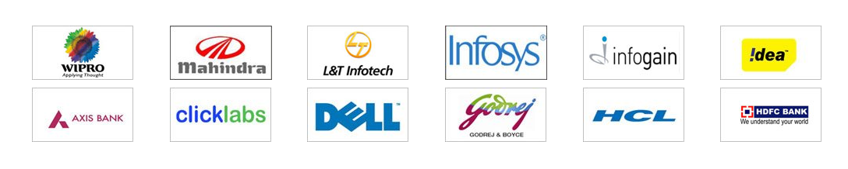

**FRANCHISE:**

**Infowiz** offering Industrial Training Franchise Opportunity in every district & states of India. **Infowiz** is a well known brand for Industrial training program in Technical Education. Presently **Infowiz** is running its Institutes in **Mohali/Chandigarh, Bathinda** and coming up with more Industrial training institutes in PAN India.

## Our Work

We work in PHP, .NET, Java, IOS, Android apps, Word Press, Joomla, Bootstrap, Civil and Mechanical Softwares.

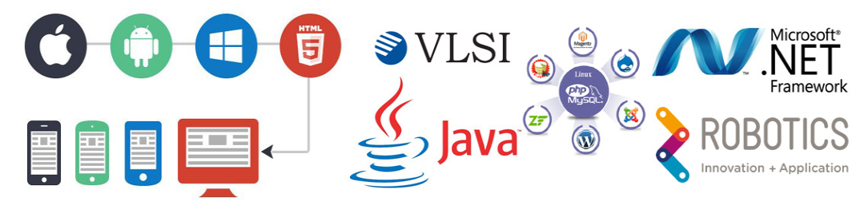

**Chandigarh Branch: Phone:**

SCO 118-120, (Near State Bank Of India), +91 172-4567-888

Sub City Center, Sector 34-A, Chandigarh, +91 9888-500-888

Pin Code 160022. +91 9888-600-888

**Bathinda Branch: Phone:**

First floor, Crown Tower, 100 +91 164-5007-088

Feet Road, Bathinda, +91 9023-500-888

Pin Code 151001. +91 9023-600-88

**WEB SITE:** [info@infowiz.co.in](mailto:info@infowiz.co.in), [www.infowiz.co.in](http://infowiz.co.in/)

**ROADMAP OF FUTURE:**

***INFOWIZ’s*** future plans include regional and national expansion through both COCO and FOFO business models. Our 1st COCO branch is already operational at Bathinda. Being an ISO certified company and member of CII we have attained very high level of accomplishments in the Industrial training business that we want to take to masses. Infowiz is committed to develop its strengths & core competencies with continuous research & technical excellence. It would never cease to embrace and add latest technological advancements in the field of trainings and pass the same to the students as and when demand will arise, creating the best and most modern atmosphere for learning.

**Chandigarh Branch Road Map:**

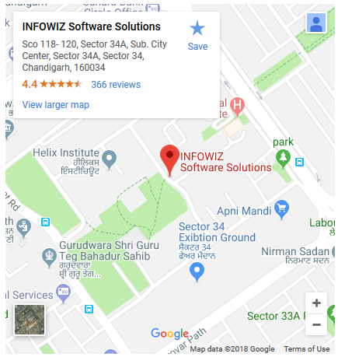

**What is Python?**

Python is a popular programming language. It was created in 1991 by Guido van Rossum.

It is used for:

* web development (server-side),
* software development,
* mathematics,
* system scripting.

**What can Python do?**

* Python can be used on a server to create web applications.
* Python can be used along side software to create workflows.
* Python can connect to database systems. It can also read and modify files.
* Python can be used to handle big data and perform complex mathematics.
* Python can be used for rapid prototyping, or for production-ready software development.

**Why Python?**

* Python works on different platforms (Windows, Mac, Linux, Raspberry Pi, etc).
* Python has a simple syntax similar to the English language.
* Python has syntax that allows developers to write programs with fewer lines than some other programming languages.
* Python runs on an interpreter system, meaning that code can be executed as soon as it is written. This means that prototyping can be very quick.
* Python can be treated in a procedural way, an object-orientated way or a functional way.

**Python Features:**

Python provides lots of features that are listed below:

***1) Easy to Learn and Use:***

Python is easy to learn and use. It is developer-friendly and high level programming language.

***2) Expressive Language:***

Python language is more expressive means that it is more understandable and readable.

***3) Interpreted Language:***

Python is an interpreted language i.e. interpreter executes the code line by line at a time. This makes debugging easy and thus suitable for beginners.

***4) Cross-platform Language:***

Python can run equally on different platforms such as Windows, Linux, Unix and Macintosh etc. So, we can say that Python is a portable language.

5) ***Free and Open Source*:**

Python language is freely available at [offical web address](https://www.python.org/). The source-code is also available. Therefore it is open source.

***6) Object-Oriented Language:***

Python supports object oriented language and concepts of classes and objects come into existence.

***7) Extensible:***

It implies that other languages such as C/C++ can be used to compile the code and thus it can be used further in our python code.

***8) Large Standard Library:***

Python has a large and broad library and provides rich set of module and functions for rapid application development.

***9) GUI Programming Support:***

Graphical user interfaces can be developed using Python.

***10) Integrated:***

It can be easily integrated with languages like C, C++, JAVA etc.

**HARDWARE AND SOFTWARE TO BE USED**

The success of any running project primarily depends upon Hardware and Software in its compilation. The hardware used in the machine should be such that it supports the software that is to be mounted for assembling the project. This project deals with the hardware and software which is available reading and easy on each and every machine given to the user.

1. Operating System: - Windows 7

2. Framework 3.5

3.Python 3.6

**Scope of the Website**

In future we can use Image recognization instead of using hetrogenious database more over High speed, accuracy and non-redundant data are the main advantages of the proposed system. In the proposed system the user is provided with a choice of data screen, which are similar in formats to the source documents. Data entry errors can be minimized through validity checks. After the verification only the data are placed the permanent database.The software can be developed further to include a lot of modules because the proposed system is developed on the view of future, for example we should develop the system as a database independent using JDBC so we can connect it to any other database, Now the proposed system is based on PC and intranet but in the future if we need to convert it intointernet then we need to change the front end only because we are developing this on the basis of OOP technology and most of the business logic’s are bounded in the class files and module like reusable components.

**PROJECT DESCRIPTION**

The project titled as **“Online Crime File Management“**is a web based application. This software provides facility for reporting online crimes, complaints, missing persons, showmostwanted person. Any Number of clients can connect to the server. Each user first makes their login to sever to show their availability. The server can be any Web Server.

The main modules in this project are:

**Modules**

* Visitors
* Registered Users
* Administrator

**The visitor module includes:**

* View Hotnews: This module help the visitor to see the latest hotnews which can updated by the admin.

**The registered user module includes:**

* Add Complaint: This module help the user to report online complaints.
* Add Crime report: This module help the user to report online crimes.
* Add Missing person: This module help the user to report online missing persons details also we have to add photos of missing person using hetrogenious database.
* View Missing persons: This module help the user to view all the missing person details.
* View Mostwanted persons: This module help the user to view all mostwanted persons which can be given by the administrator.
* Edit Complaint: This module help the user to edit his complaint details.
* Edit Account: This module help the user to update his or her profile.
* View complaint status: This module allows us to view the status of all complaint that you have posted earlier.
* View crime status: This module allows us to view the status of the all crimes that you have posted earlier.
* Add and View feedback: This module helps the user to add and view feedbacks

**The administrator module includes:**

* View and reply user complaint: This module helps the admin to view and reply user’s complaint details
* View and reply user crimes: This module helps the admin to view and reply user’s crimes details
* New admin: This module used for add new admin
* Add and delete latest hotnews: This module helps the admin to add and delete latest hotnews.
* View and delete user’s feedback: This module helps the amin to add and delete user’s feedback
* Add, delete and view mostwanted persons: This module helps the amin to add, delete and view mostwanted person details
* Add, delete and view missing persons: This module helps the amin to add, delete and view missing person details
* Add and view Criminal registeration: This module helps the amin to add and view criminal registrations
* Add and view FIR: This module helps the amin to add and view Fir reports
* Add and view history sheet: This module helps the amin to add and view history reports
* View and delete all complaint reply: This module helps the amin to view and delete complaint reply.
* Add and view prisoner report: This module helps the amin to add and prisoner reports
* Change password: This module helps the amin to update his or her password

**REQUIRMENT ANALASIS**

**Hardware Requirements**

|  |  |
| --- | --- |
| **Number** | **Description** |
| 1 | Intel core ,WIN xp/7/vista |
| 2 | 320 MB RAM |

**Software Requirements**

|  |  |
| --- | --- |
| **Number** | **Description** |
| 1 | Windows XP –7 |
| 2 | Python 3.6 |
| 3 | MySql |
| 4 | IIS server/ WAMPSERVER |
| 5 | HTML/DHTM/AJAX/JavaScript/CSS/  flash 8 |

**ScreenShots**

**Home Page**

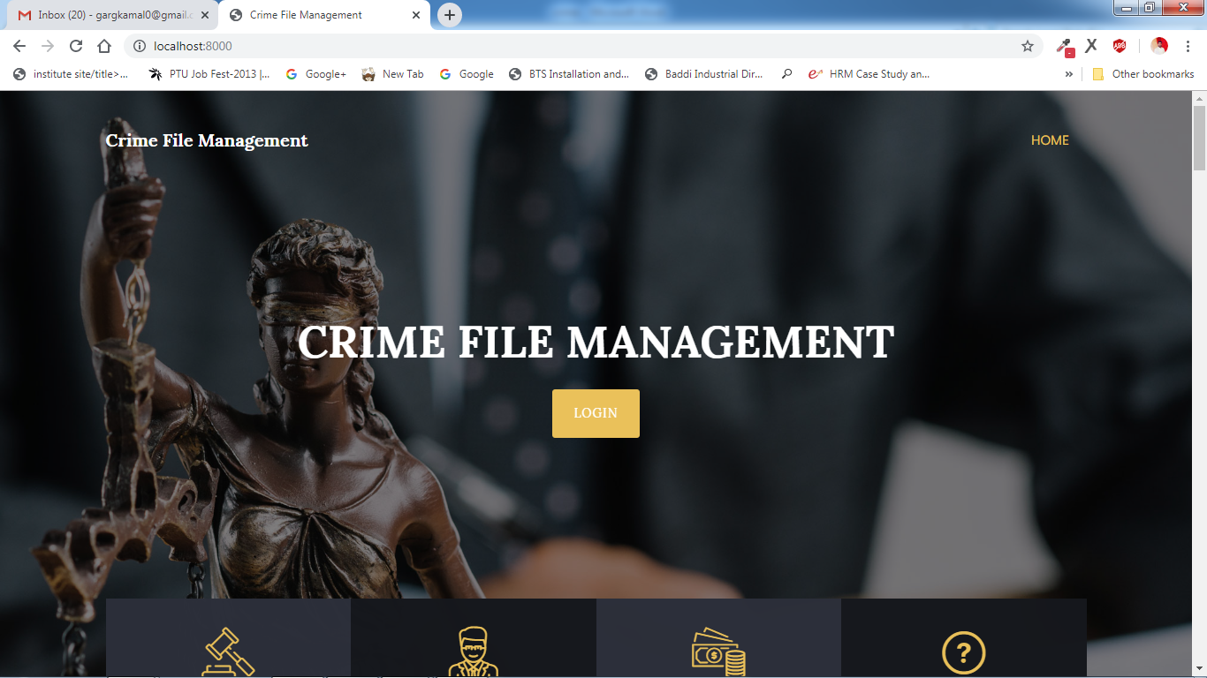

**Login Panel**

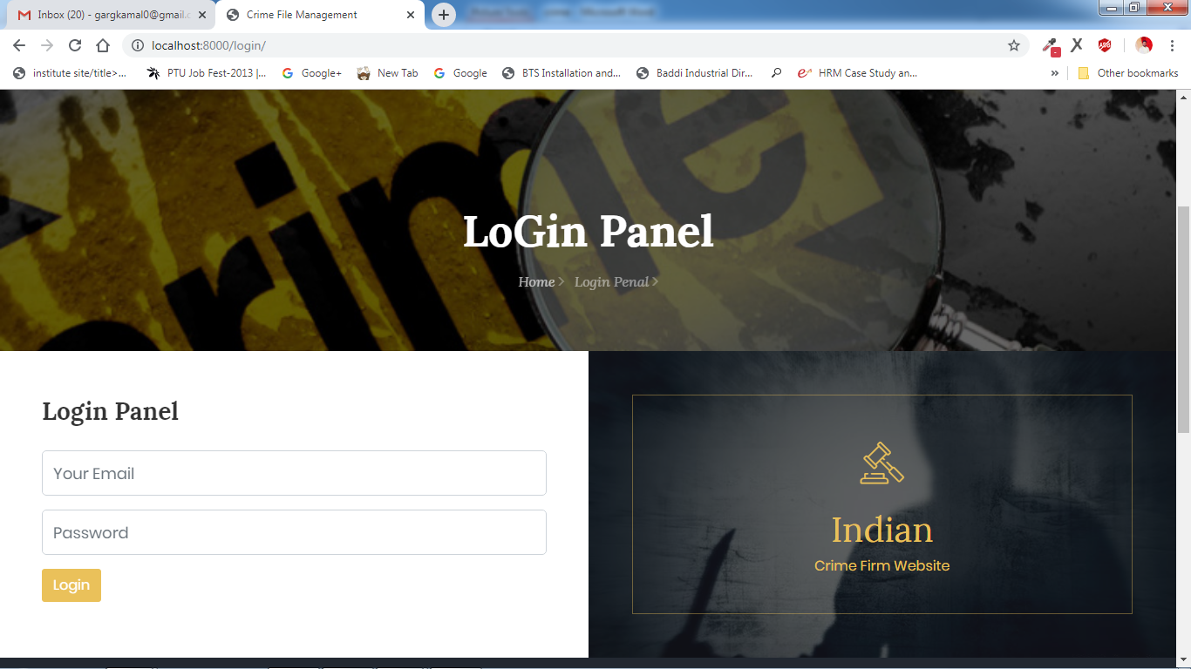

**Admin Panel**

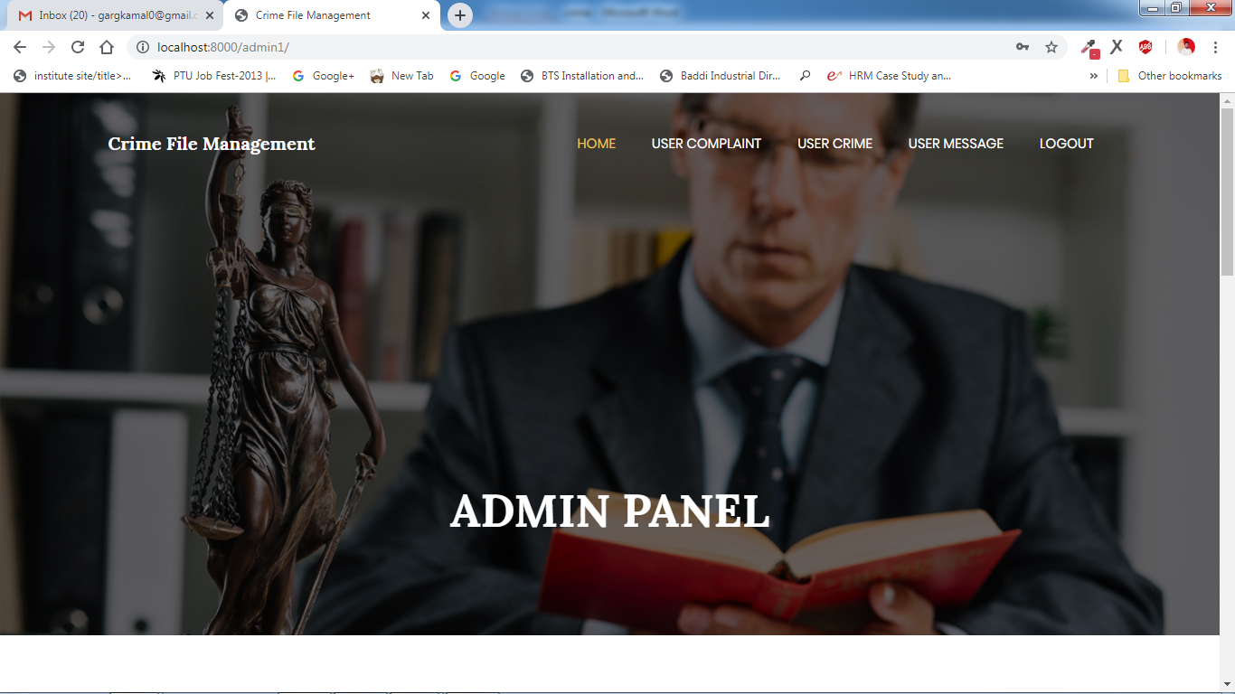

**View All Complaint**

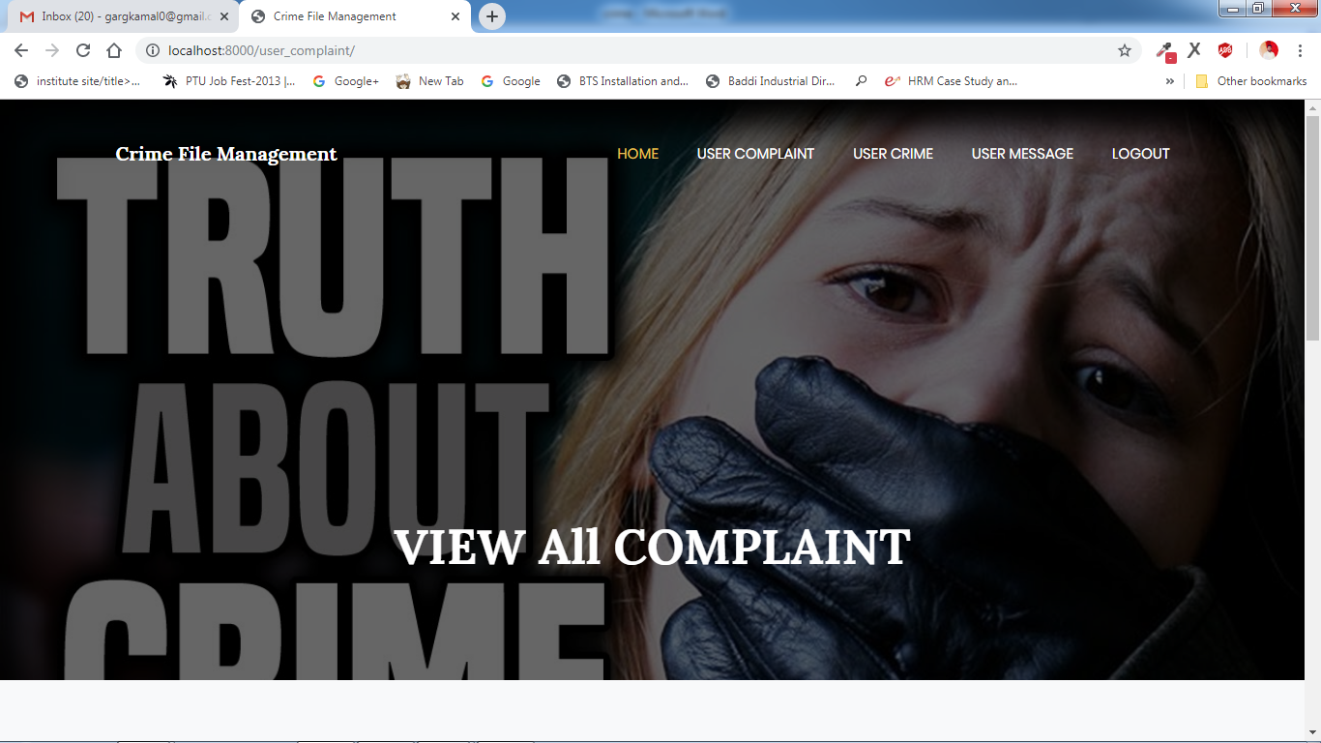

**Register Now**

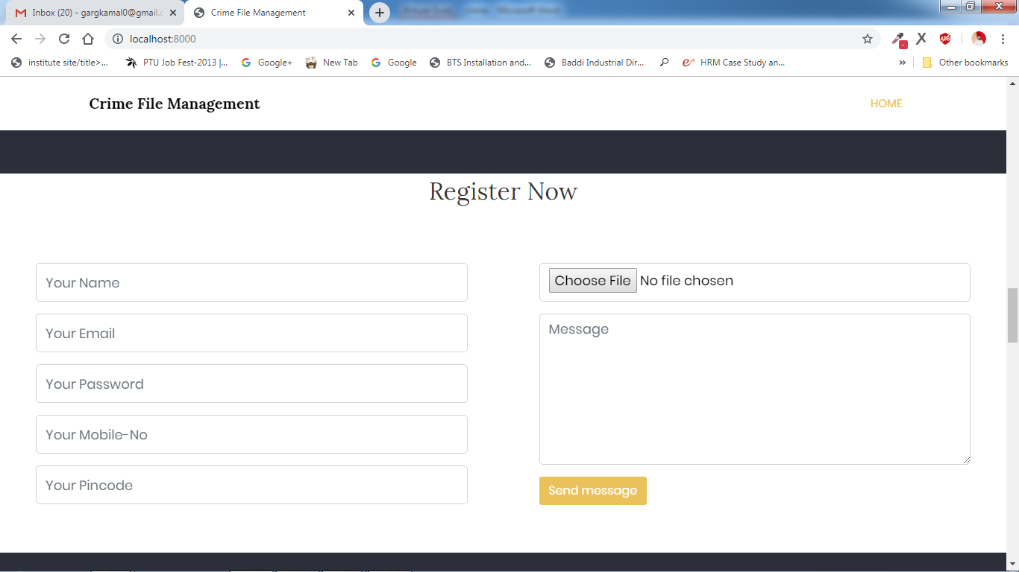

**View All Missing Person**

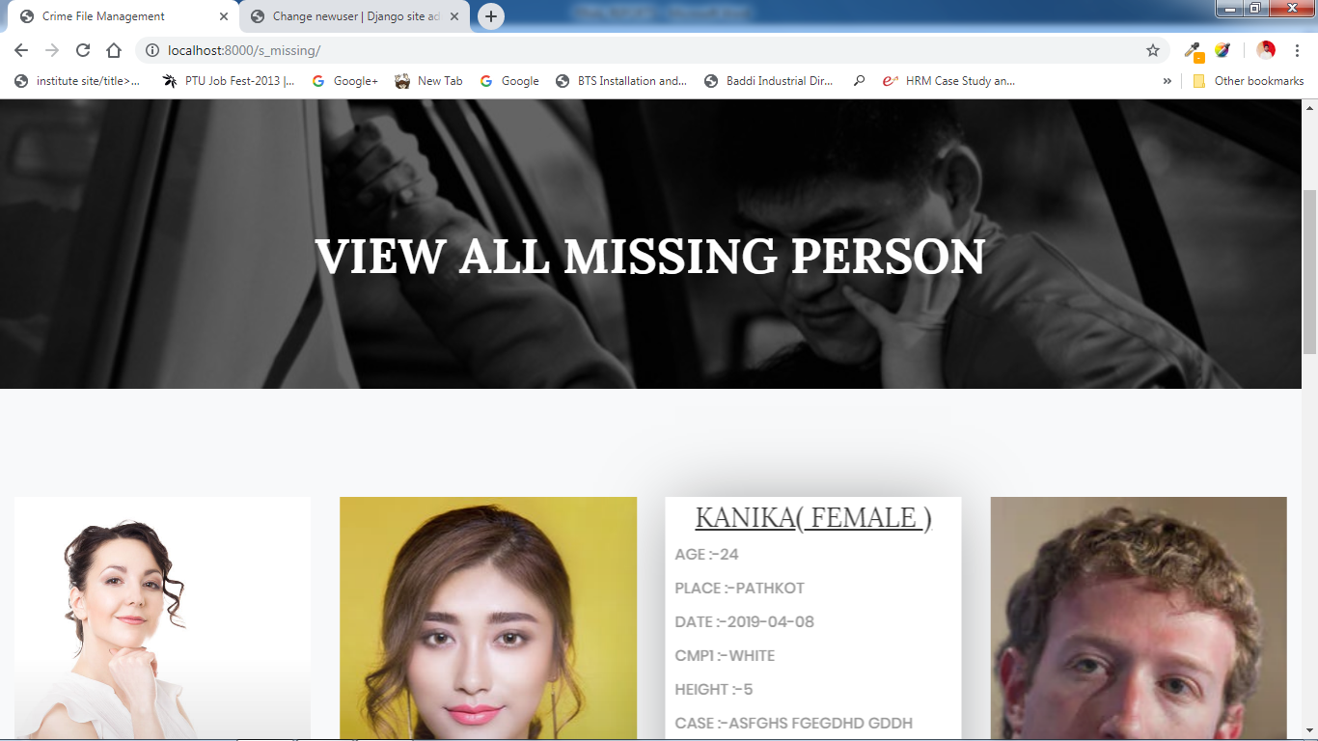

**Admin Account**

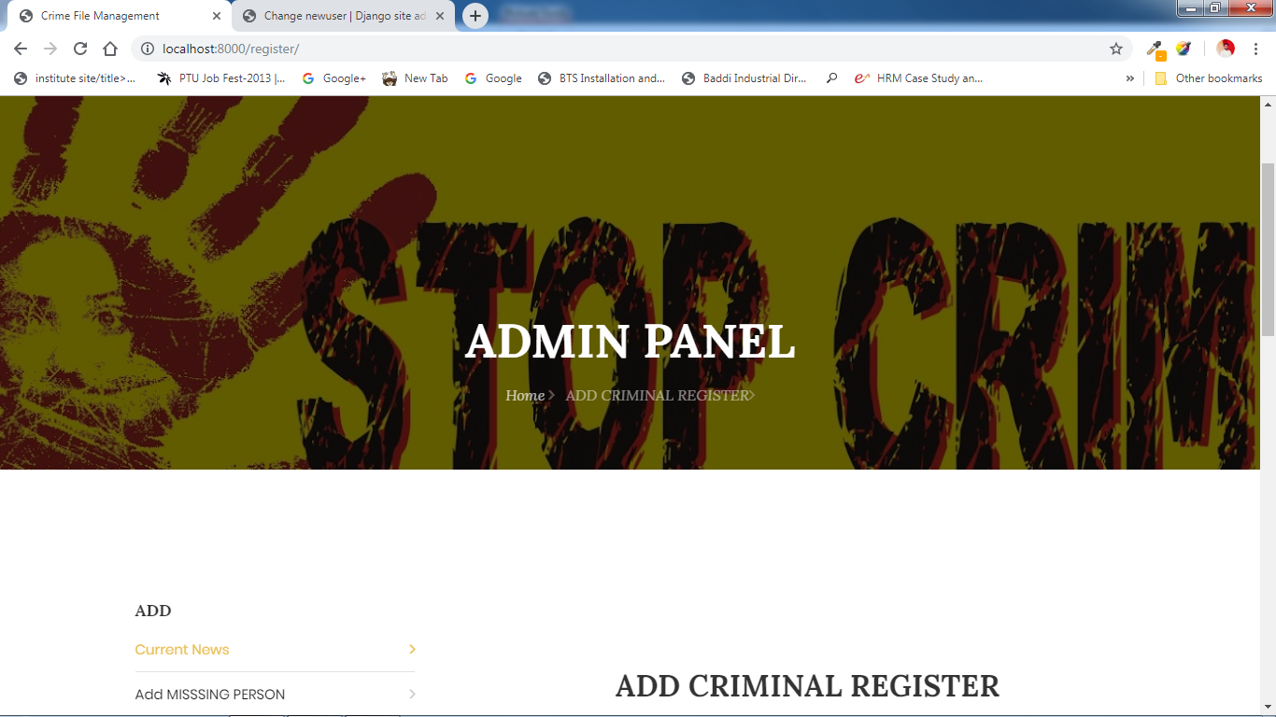

**PROJECT TEAM**

|  |  |  |
| --- | --- | --- |
| **Sr. No.** | **Team Member** | **Roll no** |
| **1.**  **2.** | **MandeepKaur**  **Romika** | **105512142923**  **105512177157** |